2024 Arbor Day Accomplishment Report
and Reimbursement Request (revised 03/2024)
This grant is available to Tree City USA communities and Tree campus USA institutions.

The intent of this grant is to provide funding for landscape-sized ceremonial tree(s) (1.5” caliper or greater) and associated supplies (stakes, watering bags, mulch, etc.) to meet the Tree City/Campus standard for an annual Arbor Day public ceremony. Trees must be planted on public property.

Applicants must document a minimum of 50% matching expenses, (e.g., $250 if requesting the maximum $500). “Match” may include staff time, donated materials, equivalent costs associated with use of donated equipment, and volunteer labor, including planning meetings, site preparation, planting, etc. (Note: The current national adult volunteer value per hour is $37.63.)
PLEASE NOTE: This form must be submitted to WA DNR Urban & Community Forestry program within 30 days of your event. Failure to do so may result in forfeiture of grant reimbursement.

Applicant: Click or tap here to enter text. Contact Person: Click or tap here to enter text.
Phone: Click or tap here to enter text. Email: Click or tap here to enter text.
Remit reimbursement to:
Name: Click or tap here to enter text. DUNS: Enter text.
Address: Click or tap here to enter text. City: Click or tap here to enter text. Zip: Enter text.
Date proclamation was read (cities only; leave blank if Tree Campus) Click or tap here to enter text.
Actual date of Arbor Day celebration Enter date. Est. # of people attending event Enter text.
Description of Expenses for Reimbursement  (landscape-sized trees & supporting materials, if appropriate) | *Reimbursement Request (total should not exceed $500)
 | $
 | $
 | $
 | $
TOTAL | $

Description of Matching Expenses  (volunteer time, donated materials, and city-paid expenses) | Value of Matching Expenses  City Other
 | $ | $
 | $ | $
 | $ | $
TOTAL | $ | $
*NOTE: Reimbursable costs include landscape-sized trees and materials related to tree planting and care such as mulch, stakes, water bags, etc. Receipts are required for all reimbursable expenditures. Please attach receipts to the completed form.
Seedling purchases are not reimbursable, but may be used as a matching expense.

List the number and kind of tree(s) you planted as part of the Arbor Day celebration:
(Cost of should be included in the expense detail above.)
Number of Trees | Species of Tree(s)  (seedling purchases are not reimbursable)

- Who is responsible for water and maintenance of the tree(s): Click or tap here to enter text.
- Please tell us about the event. Include a place name, address, or GPS coordinates of the planting site(s) that can be used to locate the tree in the future. Include unique activities or anything else we should know about your celebration.
Project GPS Coordinates (reference point latitude/longitude): Click or tap here to enter text.
About the project: Click or tap here to enter text.

(add additional pages, as appropriate).
- Please include a photo of the tree(s). (Note: We love photos of children; however, DNR requires a signed parental consent form in order to publish the photo. Please use the attached photo release form, if you’d like us to highlight your event and include photos of children under the age of 18.)
- Include documentation of the event with your reimbursement request, (this might include newspaper clippings, handouts, screen shots of social media postings, or other materials).

Please complete Grant Reimbursement Checklist on Page 3…
Grant Reimbursement Checklist: Please click on the boxes below to insert a check:
☐ I understand that only landscape-sized trees and materials directly related to planting ceremonial tree(s) are reimbursable. (Seedling purchases and staff time are not reimbursable).
☐ Trees are sited, or appropriate species planted, so they will not interfere with overhead utility wires at maturity. (mature height under utility wires is equal to or less than 30’)
☐ I understand that DNR will reimburse up to $500 toward expenses related to purchasing a landscape-sized ceremonial Arbor Day tree and supporting materials.
☐ I understand that I must document "matching funds” expenses equal to a minimum of 50% of the requested reimbursement. The value of volunteer time, donated materials, and city-paid expenses that exceed $500 can count as match.
☐ I have listed all expenses incurred during the Arbor Day event individually in the form below.
☐ I have included documentation for all reimbursable expenses, (receipts, paid invoices, etc.)
☐ I have included a photo of the planted tree and a description of the location in the event narrative.
☐ I have included a narrative and documentation describing Arbor Day activities, (examples of documentation: newspaper article, photos, web pages, etc.)
NOTE: CFDA # 10.664

- Return this form and all attachments to: urban_forestry@dnr.wa.gov, with “AD Reimbursement Request _ [Name of Community]” in the subject line.
- For questions, please contact Julia Kast, Julia.Kast@dnr.wa.gov 564-669-3294 or Scott Chambers, Scott.Chambers@dnr.wa.gov, 564-233-9299

Signature of Contact Person:
Thanks for participating and KEEP UP THE GOOD WORK!

Funds for this grant were provided by the USDA Forest Service Urban and Community Forestry Program, administered through the State of Washington Department of Natural Resources Urban and Community Forestry Program.
The USDA is an equal opportunity provider and employer.
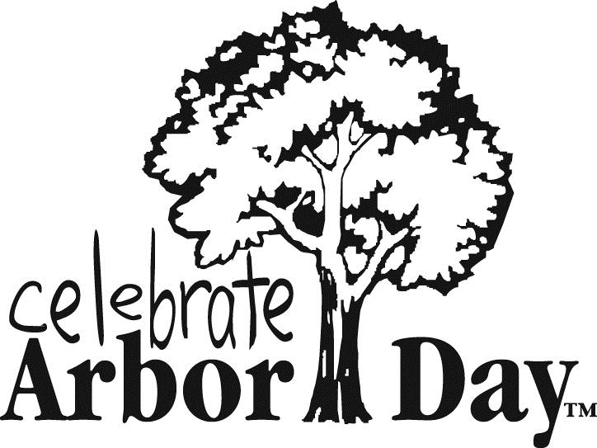

Visual Asset Release Form

I, First Name Last Name , hereby authorize and consent to the use the visual asset(s) listed below by the State of Washington Department of Natural Resources for appropriate purposes, including but not limited to: still photography, video, electronic and print publications, and websites. I give this consent with no claim for payment.
(Please list assets on next page.)
Signature Date
Phone (in case we need to contact you). Email
For a child under 18 years of age, complete the form below.
I, First Name Last Name , Parent/Guardian of First Name Last Name , hereby authorize and consent to the use of his/her visual image by the State of Washington Department of Natural Resources for appropriate purposes, including but not limited to: still photography, video, electronic and print publications and websites. I give this consent with no claim for payment.
(Please list assets on next page.)
Signature Date
Phone (in case we need to contact you). Email
DNR Policy on Publication of Visual Assets requires that a signed release form must be obtained from every subject photographed or recorded with the following two exceptions:
- Adults attending a public meeting, event, or gathering
- Employees of the Washington State Department of Natural Resources

For children enrolled in grades K-12, the release must be signed by a parent or guardian. Ordinarily, for school-connected activities, the parents sign a blanket release that is kept on file at the school. It

is our responsibility to confirm this with the teacher, school, or organization in every case of a field trip, volunteer activity, or situation that we might want to photograph or record; and, if there is no release on file, we must obtain individual releases and keep them permanently on file.
Asset 1: Description Type (photo/video, etc.) Allow usage in perpetuity ☐ OR Allow usage until (dd/mm/yy) Allow modification ☐

Asset 2: Description Type (photo/video, etc.) Allow usage in perpetuity ☐ OR Allow usage until (dd/mm/yy) Allow modification ☐

Asset 3: Description Type (photo/video, etc.) Allow usage in perpetuity ☐ OR Allow usage until (dd/mm/yy) Allow modification ☐

Asset 4: Description Type (photo/video, etc.) Allow usage in perpetuity ☐ OR Allow usage until (dd/mm/yy) Allow modification ☐

Asset 5: Description Type (photo/video, etc.) Allow usage in perpetuity ☐ OR Allow usage until (dd/mm/yy) Allow modification ☐

Asset 6: Description Type (photo/video, etc.) Allow usage in perpetuity ☐ OR Allow usage until (dd/mm/yy) Allow modification ☐

Asset 7: Description Type (photo/video, etc.) Allow usage in perpetuity ☐ OR Allow usage until (dd/mm/yy) Allow modification ☐

