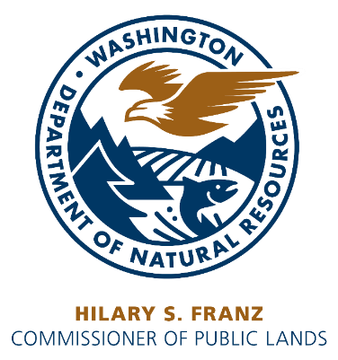

Application to Lease State Lands

I, , hereby apply to lease lands located in (Describe portion of Section, if applicable) Section _____, Township _____ North, Range _____ East West, W.M., County, Washington, containing acres, more or less.

Enclose a $25.00 application fee. Applications from public agencies do not require an application fee. All remittances are made payable to the Department of Natural Resources.

Please answer all questions fully:

1. How do you plan to use the land during the lease period?

2. Is any person living on the land? Yes No If Yes, Name: ____________

3. List all improvements (such as fences) on the property showing location.

IMPROVEMENTS | LOCATION

4. Acres in cultivation _______ Grazing _______ Other Uses _______ Specify use _________

5. Can the land be irrigated? Yes No Is there stockwater on the land? Yes No

State source and condition of the water supply:

Additional Information:

All answers and statements are true and complete to the best of my knowledge. I understand that untruthful or misleading statements are cause for rejection of this application.

Dated this ____ day of , 20___.

FOR OFFICIAL USE ONLY

Amount Received $____________________

Date ___________________ Initials ___________

Lease No. ________________________

Grant: ___________________________

Contact Person ___________________,___________ Region
___________________________________________________
Applicant Name (Print)

___________________________________________________
Business Name (if applicable)

___________________________________________________
Mailing Address
__________________________________________________
City, State, Zip

___________________________________________________
UBI #

___________________________________________________
Signature

INSTRUCTIONS

1. This application to lease is for unleased land. Contact DNR region office to confirm with DNR land manager whether the land you are applying for, is already leased. Please complete application and return with a $25.00 application fee to the Department of Natural Resources nearest Region Office listed below.

2. Additional environmental review may be required for applications for new agricultural development leases greater than 160 acres, new grazing leases greater than 640 acres, and new commercial leases.

3. When responding to question 1 (your lease plans), please include information regarding the following if applicable: Type of lease requested (e.g. commercial, agriculture, grazing, etc.); period of time requested for lease; improvement plans; type of crops; crop rotation; grazing plans; etc.

4. Department of Natural Resources' consideration of the application includes a field inspection and an administrative review to determine the impact the request will have on the management of the lands involved and to determine if the request is in accordance with the statutes of the State of Washington.

5. New leases to entities other than public agencies require public advertising and a public lease auction.

Mail this application and $25.00 Application Fee to:

For Leases in Southeast Washington Counties | For Leases in Northeast Washington Counties | All other locations
DNR Southeast Region  713 Bowers Road  Ellensburg, WA 98926 | DNR Northeast Region  225 S Silke Road  Colville, WA 99114 | Department of Natural Resources  Product Sales and Leasing Division  PO Box 47014  Olympia, WA 98504-7014

