To access the Forest Practices enforcement report, go to http://secureaccess.wa.gov and follow the instructions below. If you already have an account and have applied for “Forest Practices Reporting”, you may skip to #6 after logging in.
- Sign into SecureAccess Washington (SAW) at http://secureaccess.wa.gov. If you don’t have an account, select “Create one” and follow the instructions provided. Once you have registered for your account, continue with step 2.
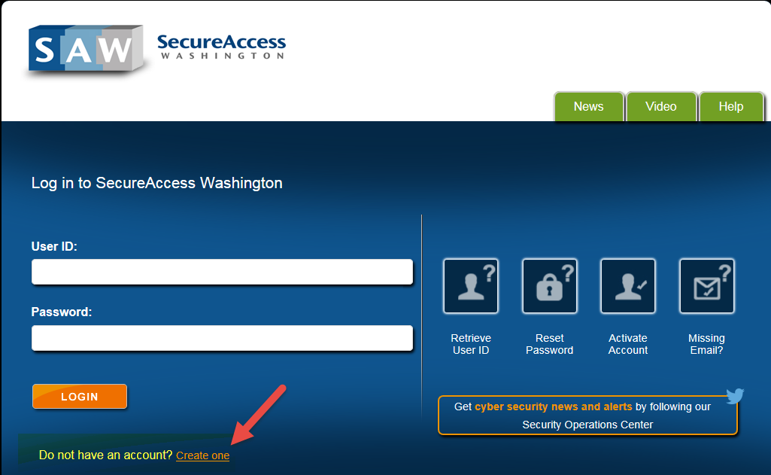
- Once you have logged in you should be directed to the “My Secure Services” tab. From there, select “Add a New Service”.
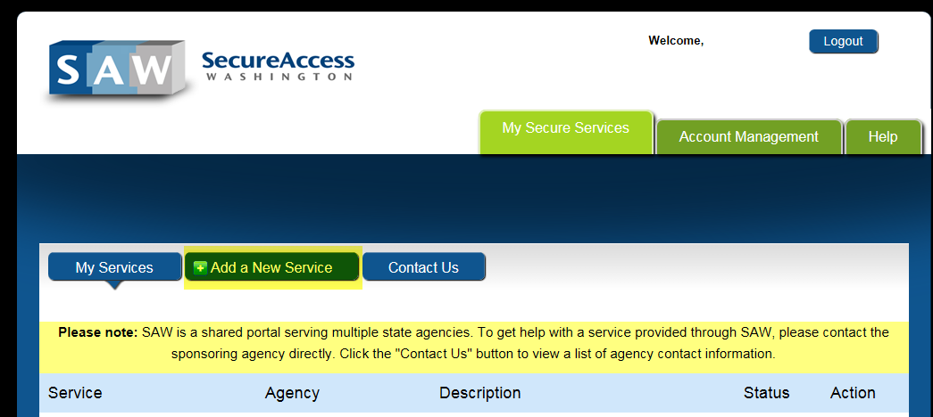
- Under “Add a New Service” select “Department of Natural Resources” from the list of agencies.
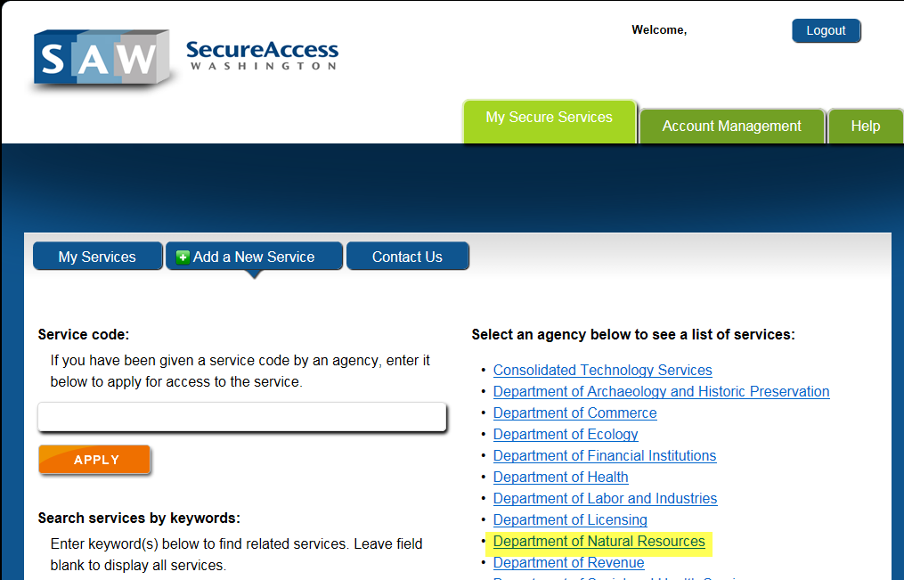
- The first option listed should be “Forest Practices Reporting”. Select “APPLY”.
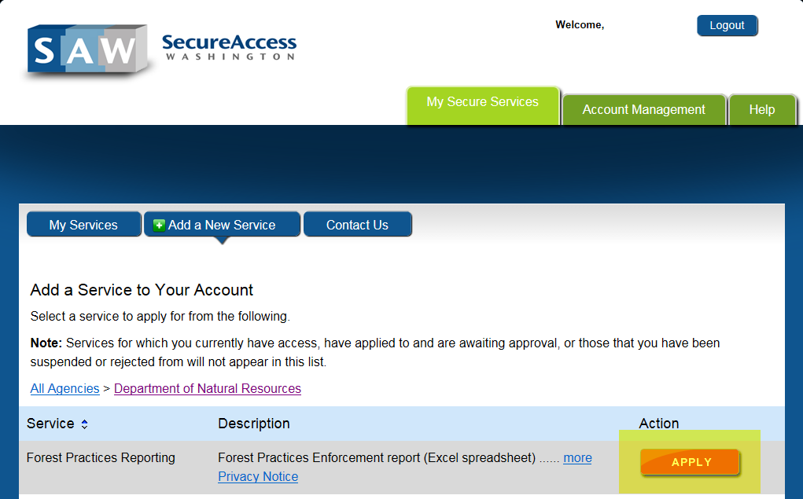
- You should be taken to a confirmation screen. Select the “My Services” tab.
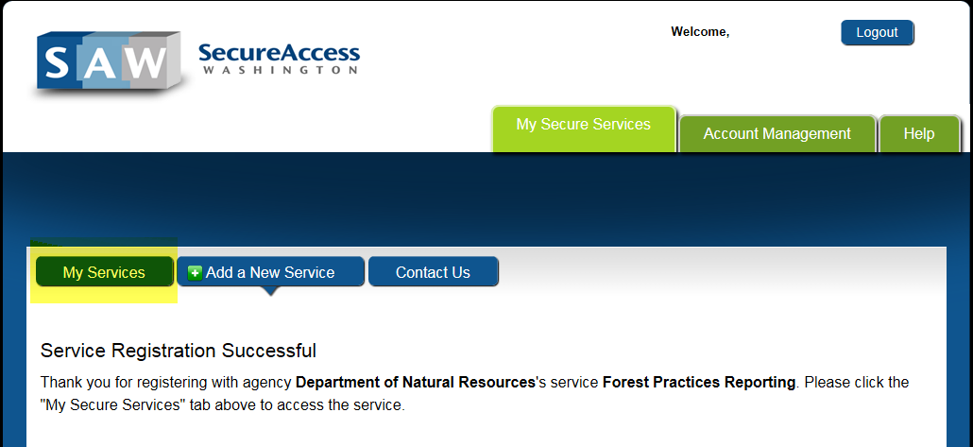
- You can now select the “Forest Practices Reporting” service from your list.
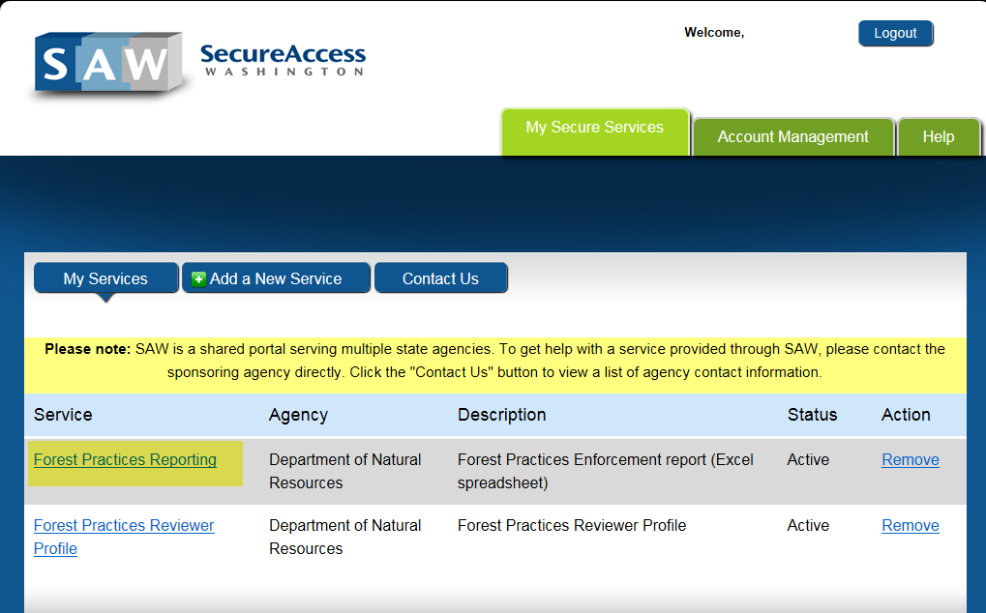

- To view the report, select “HERE” in the body of the text.
