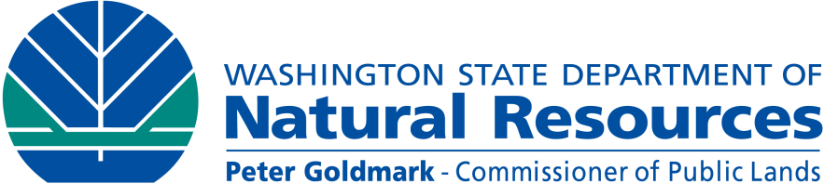
DNR Public Safety Checklist for Large Woody
Debris Projects

Proposed project:
Proponent:
Date submitted:

Factual background supplied by project proponent

- Public Use.
Describe public use of the water body. For each question, describe sources and contacts.

- What activities take place in the vicinity of the project? Describe the time of year, frequency, and popularity of the site for these uses. Document descriptions in guidebooks for canoeing, rafting, or fishing, or any internet sites. Note whether or not there is a history of accidents in the vicinity of the proposed project.

- What type of access to the area is available and at what distance from the project site?

- Have any public safety studies and/or a risk assessment been completed? Provide them.

- Provide a narrative describing any community and river user-group consultations that have been carried out, if necessary, to address public safety.

- Site Description.
Provide a general description of the water body at, upstream, and downstream of the proposed project.

- General channel description: gradient, bedform, ordinary high water width and depth, adjacent banks (e.g. steep, flat, high, vegetated, etc.).

- Range of conditions, particularly during times of peak use: flow volume and velocity, maximum depth, channel width.

- Area Description.
Provide a general description of the following at, upstream, and downstream of the proposed project, including existing hazards. Address any potential impacts of the proposed project.

- Identify any dams, water diversions, or other features that may affect the flow regime.

- Describe downstream structures such as bridges or docks.

- Describe land use in the immediate vicinity (e.g. residential, forest land, etc.).

- Identify relationship to towns, cities, or other population centers.

- Project Description.
Provide a narrative describing the proposed project.

- Where is the project relative to the water body? (e.g. at the bend of river; at the margin of a channel; in a backwater; how far from the shoreline; etc.).

- How is the project designed to interact with the channel and the flow?

- What is the minimum line of sight distance navigating up and down stream?

- How long will it take floating users to reach the project during the most frequent or expected use (taking into account the most likely direction of travel)?

- Is the project located in a position where people can readily avoid the structure and other nearby hazards?

- Describe how the project will protect public safety. Project proponents are encouraged to develop designs consistent with the State of Washington Integrated Streambank Protection Guidelines and Stream Habitat Restoration Guidelines, which promote public safety. Describe how these documents were used in the project design and any known deviations from them, if applicable.

- Licensed engineers with fluvial geomorphological and/or hydrology experience in safely designing large wood restoration projects are strongly encouraged as part of the restoration team. What is the experience of the designer?

- Specify what flood event the project is designed to withstand.

- Anticipated Outcomes.
Provide a narrative describing the anticipated outcomes of the proposed project.

- Describe how the project is anticipated to affect geomorphic characteristics of the water body at, upstream, and downstream of the proposed project as previously described in number 4 above. As applicable, identify how the project will interact with existing hazards or create new hazards by altering the channel/banks, water depths, currents, wood migration, or flooding.

- How will the project affect people’s ability to safely access and exit the water?

- Does the project increase the relative risk to the typical user at this portion of the water body?

- What public safety and resource risks are associated with structural failure?

- Mitigation Measures.
Provide a narrative describing mitigation measures for the proposed project.

- What structural or design elements were applied to this project to minimize public safety risks?

- What is the frequency and term of post-construction monitoring to assess structural integrity of the project and ease of avoidance by water users? What is the performance threshold for success or failure? How will this information be reported? What is the contingency plan if problems are detected or for failed performance?

- Provide a narrative describing the public awareness/education strategy, if necessary, to address public safety. Identify proposed public safety notices.

- How and where will safety signage be used to protect in-water users? This detail should be included on the plan view of the design.

